options =

[**TrainingOptionsSGDM**](matlab:helpPopup%20nnet.cnn.TrainingOptionsSGDM) with properties:

Momentum: 0.1000

InitialLearnRate: 1.0000e-03

LearnRateSchedule: 'none'

LearnRateDropFactor: 0.1000

LearnRateDropPeriod: 5

L2Regularization: 1.0000e-04

GradientThresholdMethod: 'l2norm'

GradientThreshold: Inf

MaxEpochs: 1000

MiniBatchSize: 20

Verbose: 1

VerboseFrequency: 50

ValidationData: [1×1 augmentedImageDatastore]

ValidationFrequency: 4000

ValidationPatience: Inf

Shuffle: 'every-epoch'

CheckpointPath: ''

ExecutionEnvironment: 'gpu'

WorkerLoad: []

OutputFcn: []

Plots: 'training-progress'

SequenceLength: 'longest'

SequencePaddingValue: 0

SequencePaddingDirection: 'right'

DispatchInBackground: 0

ResetInputNormalization: 1

Initializing input data normalization.

|======================================================================================================================|

| Epoch | Iteration | Time Elapsed | Mini-batch | Validation | Mini-batch | Validation | Base Learning |

| | | (hh:mm:ss) | Accuracy | Accuracy | Loss | Loss | Rate |

|======================================================================================================================|

| 1 | 1 | 00:00:03 | 15.00% | 21.21% | 2.1456 | 1.9684 | 0.0010 |

| 17 | 50 | 00:00:41 | 30.00% | | 1.7684 | | 0.0010 |

| 34 | 100 | 00:01:23 | 45.00% | | 1.5966 | | 0.0010 |

| 50 | 150 | 00:02:08 | 65.00% | | 1.2674 | | 0.0010 |

| 67 | 200 | 00:02:52 | 55.00% | | 1.1027 | | 0.0010 |

| 84 | 250 | 00:03:35 | 60.00% | | 1.0049 | | 0.0010 |

| 100 | 300 | 00:04:20 | 80.00% | | 0.5784 | | 0.0010 |

| 117 | 350 | 00:05:05 | 65.00% | | 0.8804 | | 0.0010 |

| 134 | 400 | 00:05:51 | 80.00% | | 0.5427 | | 0.0010 |

| 150 | 450 | 00:06:36 | 80.00% | | 0.4537 | | 0.0010 |

| 167 | 500 | 00:07:22 | 80.00% | | 0.4466 | | 0.0010 |

| 184 | 550 | 00:08:08 | 80.00% | | 0.4545 | | 0.0010 |

| 200 | 600 | 00:08:53 | 75.00% | | 0.6034 | | 0.0010 |

| 217 | 650 | 00:09:39 | 95.00% | | 0.2277 | | 0.0010 |

| 234 | 700 | 00:10:25 | 90.00% | | 0.2590 | | 0.0010 |

| 250 | 750 | 00:11:11 | 80.00% | | 0.3668 | | 0.0010 |

| 267 | 800 | 00:11:58 | 100.00% | | 0.1199 | | 0.0010 |

| 284 | 850 | 00:12:45 | 95.00% | | 0.1461 | | 0.0010 |

| 300 | 900 | 00:13:31 | 100.00% | | 0.0928 | | 0.0010 |

| 317 | 950 | 00:14:18 | 100.00% | | 0.1445 | | 0.0010 |

| 334 | 1000 | 00:15:08 | 95.00% | | 0.1451 | | 0.0010 |

| 350 | 1050 | 00:15:54 | 95.00% | | 0.1513 | | 0.0010 |

| 367 | 1100 | 00:16:41 | 100.00% | | 0.0918 | | 0.0010 |

| 384 | 1150 | 00:17:28 | 100.00% | | 0.0598 | | 0.0010 |

| 400 | 1200 | 00:18:13 | 100.00% | | 0.0865 | | 0.0010 |

| 417 | 1250 | 00:18:59 | 100.00% | | 0.0272 | | 0.0010 |

| 434 | 1300 | 00:19:46 | 100.00% | | 0.0449 | | 0.0010 |

| 450 | 1350 | 00:20:32 | 100.00% | | 0.0284 | | 0.0010 |

| 467 | 1400 | 00:21:20 | 100.00% | | 0.0183 | | 0.0010 |

| 484 | 1450 | 00:22:07 | 100.00% | | 0.0209 | | 0.0010 |

| 500 | 1500 | 00:22:53 | 100.00% | | 0.0172 | | 0.0010 |

| 517 | 1550 | 00:23:40 | 100.00% | | 0.0420 | | 0.0010 |

| 534 | 1600 | 00:24:27 | 100.00% | | 0.0100 | | 0.0010 |

| 550 | 1650 | 00:25:12 | 100.00% | | 0.0092 | | 0.0010 |

| 567 | 1700 | 00:26:03 | 100.00% | | 0.0337 | | 0.0010 |

| 584 | 1750 | 00:26:50 | 100.00% | | 0.0081 | | 0.0010 |

| 600 | 1800 | 00:27:36 | 100.00% | | 0.0056 | | 0.0010 |

| 617 | 1850 | 00:28:23 | 100.00% | | 0.0040 | | 0.0010 |

| 634 | 1900 | 00:29:10 | 100.00% | | 0.0138 | | 0.0010 |

| 650 | 1950 | 00:29:57 | 100.00% | | 0.0072 | | 0.0010 |

| 667 | 2000 | 00:30:45 | 100.00% | | 0.0024 | | 0.0010 |

| 684 | 2050 | 00:31:31 | 100.00% | | 0.0022 | | 0.0010 |

| 700 | 2100 | 00:32:17 | 100.00% | | 0.0251 | | 0.0010 |

| 717 | 2150 | 00:33:04 | 100.00% | | 0.0063 | | 0.0010 |

| 734 | 2200 | 00:33:52 | 100.00% | | 0.0024 | | 0.0010 |

| 750 | 2250 | 00:34:39 | 100.00% | | 0.0089 | | 0.0010 |

| 767 | 2300 | 00:35:25 | 100.00% | | 0.0051 | | 0.0010 |

| 784 | 2350 | 00:36:13 | 100.00% | | 0.0031 | | 0.0010 |

| 800 | 2400 | 00:37:01 | 100.00% | | 0.0063 | | 0.0010 |

| 817 | 2450 | 00:37:47 | 100.00% | | 0.0073 | | 0.0010 |

| 834 | 2500 | 00:38:34 | 100.00% | | 0.0022 | | 0.0010 |

| 850 | 2550 | 00:39:20 | 100.00% | | 0.0036 | | 0.0010 |

| 867 | 2600 | 00:40:07 | 100.00% | | 0.0038 | | 0.0010 |

| 884 | 2650 | 00:40:58 | 85.00% | | 0.4747 | | 0.0010 |

| 900 | 2700 | 00:41:46 | 100.00% | | 0.0434 | | 0.0010 |

| 917 | 2750 | 00:42:34 | 100.00% | | 0.0207 | | 0.0010 |

| 934 | 2800 | 00:43:20 | 100.00% | | 0.0113 | | 0.0010 |

| 950 | 2850 | 00:44:07 | 100.00% | | 0.0064 | | 0.0010 |

| 967 | 2900 | 00:44:54 | 100.00% | | 0.0106 | | 0.0010 |

| 984 | 2950 | 00:45:41 | 100.00% | | 0.0113 | | 0.0010 |

| 1000 | 3000 | 00:46:28 | 100.00% | 72.73% | 0.0101 | 1.2169 | 0.0010 |

|======================================================================================================================|

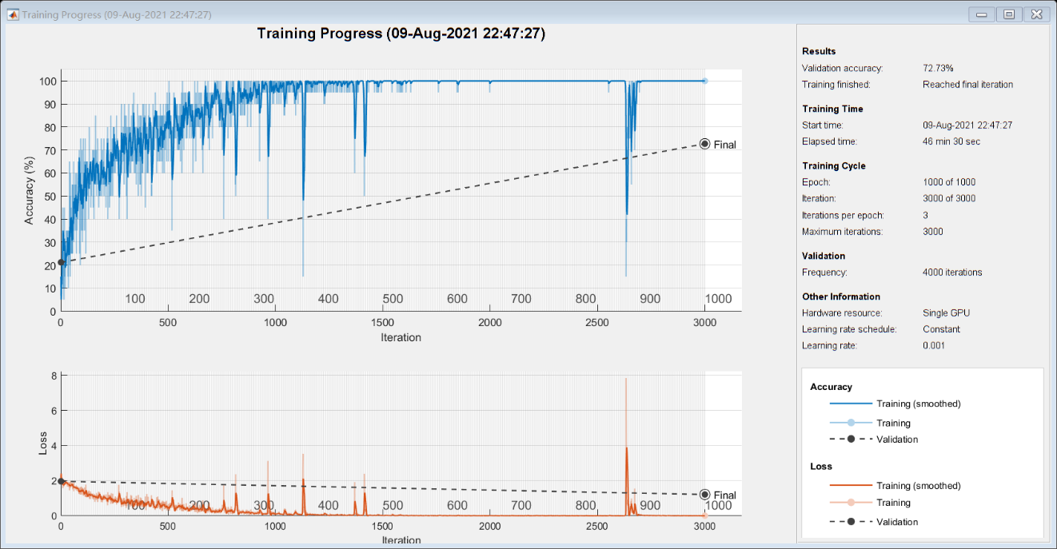

net =

[**DAGNetwork**](matlab:helpPopup%20DAGNetwork) with properties:

Layers: [144×1 nnet.cnn.layer.Layer]

Connections: [170×2 table]

InputNames: {'data'}

OutputNames: {'output'}

traininfo = struct with fields:

TrainingLoss: [1×3000 double]

TrainingAccuracy: [1×3000 double]

ValidationLoss: [1×3000 double]

ValidationAccuracy: [1×3000 double]

BaseLearnRate: [1×3000 double]

FinalValidationLoss: 1.2169

FinalValidationAccuracy: 72.7273